COMPUTER ARCHITECTURE NOTES

Performance Improvements in Computing
- Improvements in Semiconductor Technology:
  - Feature size: Shrinking transistor sizes allowed more transistors to fit on chips, improving performance and reducing power consumption.
  - Clock speed: Increasing the clock speed of processors has been a significant factor in enhancing computational power.
- Improvements in Computer Architecture:
  - Enabled by HLL compilers and UNIX: High-Level Language (HLL) compilers made it easier to optimize code, and UNIX-based systems facilitated portability and efficiency.
  - RISC (Reduced Instruction Set Computing): Emerged in the 1980s with simpler instructions, focusing on exploiting parallelism at the instruction level through pipelining and multiple instruction issues.
RISC (Reduced Instruction Set Computer) and CISC (Complex Instruction Set Computer) are two different processor architecture designs.
- RISC focuses on simpler, uniform instructions that execute quickly, requiring more instructions to complete a task but improving performance and efficiency (e.g., ARM, RISC-V).
- CISC includes complex, variable-length instructions that can perform multiple operations in a single instruction, reducing the number of instructions needed but increasing execution time (e.g., Intel x86, AMD64). Before 1980s

Impact of Improvements
- Lightweight computers: More efficient hardware with smaller size, lower power consumption, and better performance.
- Productivity-based managed/interpreted programming languages: Languages like Java and Python emerged, prioritizing developer productivity over raw performance.

End of Instruction-Level Parallelism (ILP)
- ILP: Focused on making a single processor faster by exploiting parallelism within individual instructions.
- End of ILP: Around 2003, the performance improvement from ILP slowed down, as physical limitations prevented further increases in clock speed and transistor density.

New Models for Performance
With the end of single processor improvements, new parallelism models emerged:
- Data-Level Parallelism (DLP) (Performing the same operation on multiple data simultaneously):
  - DLP leverages SIMD (Single Instruction, Multiple Data) and vectorized operations to process multiple data points simultaneously.
  - Found in graphics processing units (GPUs), where the same task is applied across large data sets.
  - DLP is crucial for scientific, machine learning, and graphics computations.
- Thread-Level Parallelism (TLP) (Running multiple threads concurrently):
  - TLP exploits multiple threads that run independently of each other to perform tasks in parallel.
  - It is often implemented in multi-core processors, where each core executes different threads simultaneously, enhancing overall system throughput.
  - Useful in applications like web servers, where different threads handle different user requests concurrently.
- Request-Level Parallelism (RLP) (Handling multiple independent requests in parallel):
  - RLP is used in distributed systems, such as cloud computing, where different requests (often from multiple users) are processed in parallel.
  - It is essential in large-scale computing environments like data centers and warehouses, where tasks are partitioned and handled by separate servers or systems.
  - Examples include Google Translate, where tasks like image recognition, text translation, and voice conversion are handled in parallel by distributed systems.

The Shift in Processor Design
- The move from single power-hungry processors to multiple energy-efficient cores:
  - This shift, called multi-core processing, allows for better performance without significantly increasing power consumption.
  - This change, particularly since 2004, led to the transition from single-core to multi-core designs.

Limits to Performance
- Amdahl's Law:
  - Amdahl's Law describes the potential speedup of a program when a portion of it is parallelized. It highlights the limitations of parallel computing by considering the impact of the serial (non-parallel) portion of a program. It states that if a portion of the program remains serial, increasing the number of processors has diminishing returns.
  - For example, if 10% of the task is serial, the maximum performance improvement is limited to 10, no matter how many cores are added.

Decline of Moore's Law and Dennard Scaling
- Moore's Law: The prediction that the number of transistors on a chip would double every two years. This trend slowed down around 2016 due to minituarization limits and power and heat issues.
- Dennard Scaling: Refers to the observation that as transistor sizes decrease, power consumption stays constant. However, Dennard scaling ended around 2004, as further reductions in transistor size led to power and heat issues.
- End of Dennard Scaling and Moore's Law: Led to a slowdown in performance improvement, signaling the end of rapid increases in processor speeds.

Path Forward: Specialization
- As transistor improvements plateau, the path forward lies in domain-specific architectures. These are processors designed for specialized tasks (e.g., image recognition, AI processing), where the hardware is optimized to perform a narrow range of operations much more efficiently than general-purpose processors.
Classes of Computers | Description
Internet of Things/Embedded Computers | Everyday machines, sensors, actuators, low-cost processors, wide processing power range, IoT devices, smart applications
Personal Mobile Device (PMD) | Wireless devices, multimedia interfaces, low cost, energy efficiency, battery power, real-time performance, third-party software, minimal memory
Desktop Computing | Low-end netbooks to high-end workstations, price-performance optimization, compute and graphics performance, web-centric applications, declining sales
Servers | File and computing services, high availability, scalability, throughput efficiency, 24/7 operation, transaction processing, web pages served per second
Clusters/Warehouse-Scale Computers | Large-scale systems, multiple desktop computers or servers, price-performance, power efficiency, network communication, cost of power and cooling
Classes of Parallelism in Applications:
- Data-Level Parallelism (DLP): Involves performing the same operation on multiple data elements simultaneously (e.g., vector processing or matrix operations).
- Task-Level Parallelism (TLP): Involves executing different tasks or functions simultaneously, often involving different types of operations. (e.g, reading, cleaning, transforming, and saving data run in parallel in file)
Classes of Architectural Parallelism:
- Instruction-Level Parallelism (ILP): Exploits DLP at modest levels, using techniques like pipelining and speculative execution.
- Vector Architectures/GPU: Exploit DLP by applying a single instruction to multiple data items in parallel.
- Thread-Level Parallelism: Exploits DLP or TLP with tightly coupled hardware, enabling parallel thread interaction. Thread-level parallelism involves multiple threads within a single process sharing resources, while task-level parallelism involves independent tasks that may run separately on different processors.
- Request-Level Parallelism: Exploits decoupled tasks, specified by the programmer or OS, that can run in parallel.
Flynn’s Taxonomy (1966): Classifies computers based on parallelism in instruction and data streams:
- SISD (Single Instruction Stream, Single Data Stream): Uniprocessor, sequential with ILP exploitation (superscalar, speculative execution).
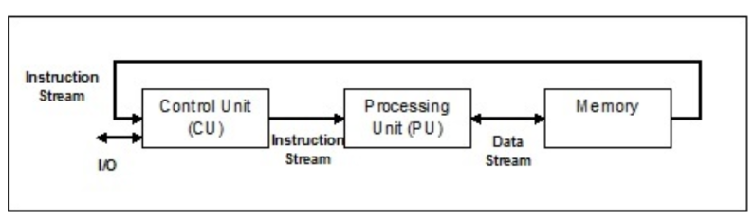
- SIMD (Single Instruction Stream, Multiple Data Streams): Multiple processors execute the same instruction on different data streams (e.g., vector architectures, GPUs, multimedia extensions).
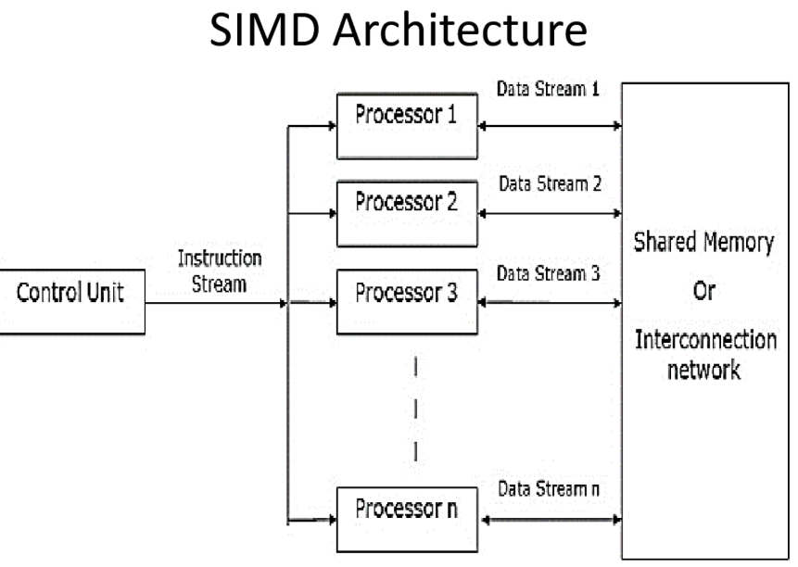
- MISD (Multiple Instruction Streams, Single Data Stream): No commercial implementation. Multiple processors execute different instructions on the same data stream
- MIMD (Multiple Instruction Streams, Multiple Data Streams): Independent processors with their own instructions and data; exploits task-level parallelism.
  - Tightly-Coupled MIMD: Threads operate in parallel.
  - Loosely-Coupled MIMD: Independent tasks operate in parallel with minimal communication (e.g., clusters, warehouse-scale computers).
Instruction Stream: Sequence of instructions fetched from memory.
Data Stream: Operations performed on data within the processor.

Computer Architecture determines how a computer’s components exchange electronic signals for input, processing, and output.
The task of computer architecture design involves determining which attributes are crucial for a new computer and then optimizing performance, energy efficiency, cost, power, and availability. It spans instruction set design, functional organization, logic design, and implementation. Historically, computer architecture mainly referred to instruction set design, but now includes a much broader scope, addressing more complex challenges like integrated circuit design, packaging, power, and cooling.
Instruction Set Architecture (ISA) is the abstract interface between hardware and software, It governs how software interacts with hardware, defining the set of instructions a processor can execute, including data types, registers, addressing modes, and control flow mechanisms.

Key Aspects of ISA: NOT INCLUDED
- Class of ISA: Modern ISAs are generally general-purpose register architectures. Some examples are the 80x86, ARMv8, and RISC-V, where operands are either registers or memory locations.
- Memory Addressing: Desktop and server computers typically use byte addressing, though some, like ARMv8, require alignment of memory objects.
- Addressing Modes: ISA defines the method to access memory. Common modes are register, immediate (constant), and displacement (with a constant offset).
- Operand Types and Sizes: These include sizes like 8-bit, 16-bit, 32-bit, and 64-bit for integers and floating-point types.
- Operations: The ISA defines a set of operations like data transfers, arithmetic, logical, and control flow instructions.
- Control Flow Instructions: These include branches, jumps, procedure calls, and returns. They may use different methods like testing condition codes or using registers.
- Encoding: The ISA defines whether the instructions are of fixed or variable length, which impacts instruction decoding and program size.

Example ISAs:
- RISC-V is an open-source RISC ISA that prioritizes simplicity, efficiency, and ease of implementation. It includes a large set of registers and supports a load-store model for memory access.
- ARMv8 also follows a RISC model and includes extensions for additional features like autoincrement addressing.

Trends in Technology:
- Integrated Circuit Logic Technology follows Moore’s Law, transistor counts doubling every 18–24 months, slowing due to physical and economic limits, shifting focus to architectural innovations, parallelism, power efficiency.
- DRAM (Dynamic RAM) used as main memory, capacity growth slowing, physical and economic challenges, alternatives like non-volatile memory (NVM), storage-class memory (SCM) emerging.
- Flash Memory (EEPROM) capacity doubling every two years, cheaper than DRAM, costlier than magnetic storage, widely used in mobile devices, SSDs, embedded systems.
- Magnetic Disk Storage rapid capacity growth, slowing due to physical limits, heat, reliability issues, future improvements through HAMR (Heat Assisted Magnetic Recording), SMR (Shingled Magnetic Recording) technologies.
- Network Technology: Network performance is essential for modern computing, and the passage touches on trends in switch performance and transmission systems.

Performance Trends: Bandwidth vs Latency:
- Bandwidth (total work done per time, like megabytes per second) has outpaced latency (time taken for an event, like disk access time) across various technologies, including microprocessors, memory, networks, and disks.
- Bandwidth improvements are often much greater than latency improvements, and designers should consider this when planning system architectures.
Bandwidth (maximum data transfer rate of a network) → Formula:

Throughput (actual data transferred over a network in a given time) → Formula:

Latency is the total time taken for data to travel from source to destination. It is the sum of:
- Propagation Time (time for a signal to travel through a medium) → Formula: Distance/Propagation Speed
- Transmission Time (time to push all bits into the link) → Formula: Message Size/Bandwidth
- Queuing Time (time spent waiting in a queue before transmission) → Varies based on network congestion
Total Latency Formula:

Scaling of Transistor Performance:
- Emphasizes the ongoing miniaturization of transistors, with feature sizes decreasing over the years. This has allowed for the increase in transistor density on chips, though the rate of scaling is slowing. smaller feature sizes (e.g., 7nm chips) increase transistor density, but wire delays create performance bottlenecks.
- As transistor density increases, more advanced technologies like multicore processors and large-scale integration (LSI) are possible.

Trends in Power and Energy:
Power Distribution and Heat Dissipation: Power must be efficiently distributed across the chip, and heat generated by power dissipation must be managed. This requires careful design of power delivery systems and cooling mechanisms.
Performance, Power, and Energy: System designers face three main concerns:
- Maximum Power Demand: Ensuring the processor doesn't exceed the power supply’s capability.
- Thermal Design Power (TDP): The sustained power consumption, which is crucial for cooling system design. If cooling is inadequate, processors can overheat and fail. TDP is defined as the maximum amount of heat generated by CPU or GPU tat its cooling system is designed to dissipate.
- Energy Efficiency: Energy is more critical than power for comparing processors for specific tasks, as energy is tied to the time taken for a task. Reducing energy consumption improves efficiency and battery life in devices like smartphones and servers.
Die: A small silicon chip containing an integrated circuit.
Wafer: A thin semiconductor slice used to fabricate multiple ICs before dicing.
CMOS (Complementary Metal-Oxide-Semiconductor): A semiconductor technology used in ICs for low power consumption and high noise immunity.
Dynamic Power: The primary power consumption in CMOS chips comes from switching transistors. The energy consumed by a transistor during a logic transition is proportional to the capacitance and the square of the voltage. Lowering voltage reduces both energy and power consumption, but the increase in transistor switching frequency over time has outpaced the reduction in voltage and capacitance, leading to higher overall power consumption.
Clock Frequency and Power: Clock frequency growth has slowed down since 2003 due to limits in power dissipation and cooling, even though single-processor performance continues to improve.
Techniques to Improve Energy Efficiency:
- Clock Gating: Inactive modules are turned off to save power.
- Dynamic Voltage and Frequency Scaling (DVFS): Power savings are achieved by adjusting voltage and clock frequency based on workload.
- Design for Typical Cases: Energy-saving features like low-power modes for DRAM and storage are used in devices like laptops and PMDs (portable mobile devices).
- Overclocking: Temporary increases in clock rate are used to boost performance when safe.
- Race-to-halt: Use a faster, less energy-efficient processor to complete tasks quickly, allowing the system to halt and save energy.
Dynamic Power: Power consumed during circuit switching (dependent on voltage, frequency, and capacitance).
Static Power: Power consumed when the circuit is idle due to leakage currents. Static power (due to leakage current when transistors are off) is becoming a significant concern.
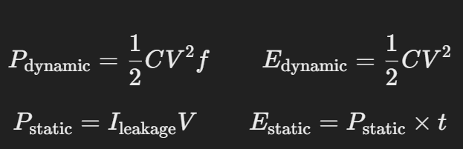

As transistor improvements slow, computer architects focus on energy efficiency. Dark silicon (powered off or underclocked) limits simultaneous transistor usage due to thermal constraints, prompting a shift in processor design. Energy and area costs vary significantly

Trends in Cost NOT INCLUDED
- Cost Reduction over Time:
  - Manufacturing costs of computer components decrease over time through the learning curve, where the percentage of successful devices (yield) improves with experience.
  - As technology matures, the cost of components like DRAM and microprocessors drops. For DRAM, price and cost generally track closely, while microprocessor prices are more complex.
- Volume Effects on Cost:
  - Increasing production volume reduces costs by decreasing learning curve time and improving manufacturing efficiency. Generally, costs decrease by about 10% with each doubling of production volume.
  - Higher volumes also reduce the per-unit share of development costs, enabling lower overall costs and prices.
- Commoditization:
  - Products that are sold by multiple vendors in high volumes become commodities, resulting in intense competition. Commodities, like standard DRAM and Flash memory, benefit from both volume and product standardization, lowering costs.
  - This competitive environment leads to better price-performance, particularly in the low-end market, although profits may be limited.
- Cost of Integrated Circuits:
  - Integrated circuit costs are a significant part of the total cost of systems, particularly in high-volume markets like embedded systems and mobile devices.
  - The cost of integrated circuits is determined by the cost of the die, testing, and packaging, with the yield (the percentage of functional chips per wafer) being a key factor.
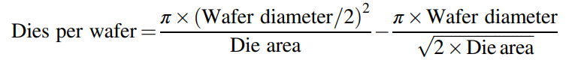
  - Die yield is influenced by the number of defects and process complexity, with smaller dies typically having higher yields. Techniques like redundancy can boost yield and reduce costs.
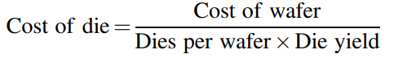

As computer margins (difference between manufacturing cost and selling price) shrink, companies allocate only a small fraction of revenue to R&D. With large-scale computing (WSCs), operational costs, especially power and cooling, are as significant as purchase costs, emphasizing energy efficiency.

Dependability
Service providers define dependability through SLAs, ensuring service accomplishment and measuring service interruption via reliability and availability metrics.

Module Reliability
- Mean Time to Failure (MTTF): Measures the continuous service accomplishment from a reference time. It's used to estimate how long a component will function before failure. The reciprocal of MTTF is the failure rate, commonly expressed in failures per billion hours (FIT).
- Mean Time to Repair (MTTR): Indicates the average time to restore service after failure.
- Mean Time Between Failures (MTBF): The total time between failures, calculated as the sum of MTTF and MTTR.
  - MTBF = MTTF + MTTR
- Failure Rate: For systems made of multiple components, the overall failure rate is the sum of individual failure rates (assuming independent failures and exponentially distributed lifetimes).

Module Availability
- Availability: Measures the proportion of time the system is operational. For non-redundant systems, availability is given by:
  - Availability = MTTF / (MTTF + MTTR)
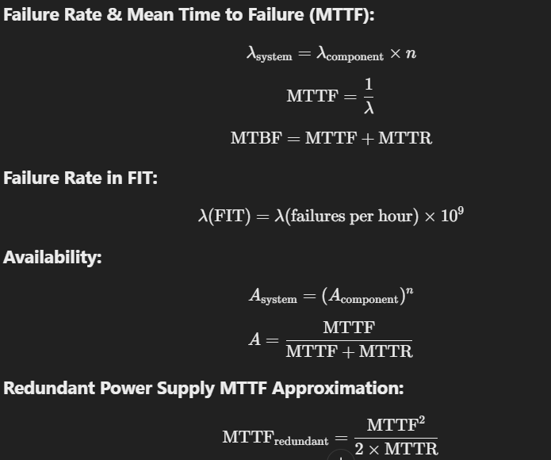
Redundancy is a key strategy to improve dependability by either adding backup components (e.g., redundant power supplies) or repeating operations to check for errors.


Measuring Performance
Performance Metrics:
- Response Time (Execution Time): The time taken for a system to complete a task (e.g., running a program).
- Throughput: The total amount of work a system can perform in a given time frame (e.g., the number of transactions processed).
- These two metrics are often inversely related: reducing response time (faster completion) can decrease throughput, and vice versa.
Execution Time:
- Wall-clock Time: The total time taken from start to end, including memory access, I/O operations, etc.
- CPU Time: Time the processor is actively working, excluding time spent waiting for I/O operations or executing other tasks.
Benchmarking:
- Real applications are preferred for measuring performance, but benchmark programs like kernels, toy programs, or synthetic benchmarks (e.g., Dhrystone) can lead to misleading results. Kernels (small key pieces of real applications), toy programs (100-line beginner programs like Quicksort), and synthetic benchmarks (fake programs mimicking real applications, e.g., Dhrystone) are used for performance evaluation.
- Benchmark Suites: A collection of different benchmarks is used to minimize the weaknesses of individual benchmarks and better characterize a computer's overall performance.

Quantitative Principles of Computer Design

Parallelism
- Exploiting Parallelism: A key way to improve performance is through parallelism, which can be used at various levels:
  - System Level: By utilizing multiple processors and storage devices to improve throughput (e.g., databases using request-level parallelism).
  - Processor Level: Parallelism in instruction execution (e.g., pipelining) reduces the time to complete an instruction sequence.
  - Digital Design Level: Set-associative caches and carry-lookahead in arithmetic units speed up operations using parallelism.

Principle of Locality
- Locality: Programs tend to reuse data and instructions they have used recently. This concept leads to more efficient memory usage.
  - Temporal Locality: Recently accessed items are likely to be accessed soon.
  - Spatial Locality: Items near each other are often accessed together.

Focus on the Common Case
- Optimizing for the Common Case: In design, prioritize the frequent case to achieve a higher impact on performance, dependability, or energy efficiency.
  - Example: Optimizing the instruction fetch and decode unit in a processor (commonly used) over a rarely used multiplier.

Amdahl’s Law
- Amdahl’s Law: Quantifies the speedup obtained by improving a portion of a system.
  - Example: If a processor improvement makes a portion 10 times faster (Speedup = 10) but that portion is only 40% of the task, the overall speedup will be around 1.56.
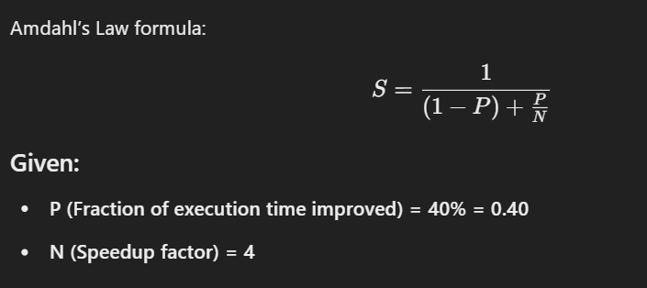
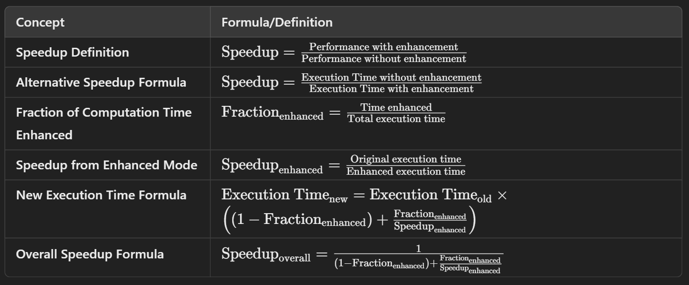
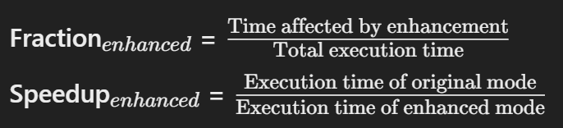

Processor Performance Equation
- CPU Time: The time to execute a program depends on the number of clock cycles and the time per clock cycle (or the clock rate).
  - CPI (Cycles per Instruction): The average number of clock cycles needed per instruction. It's a key factor in evaluating processor efficiency.
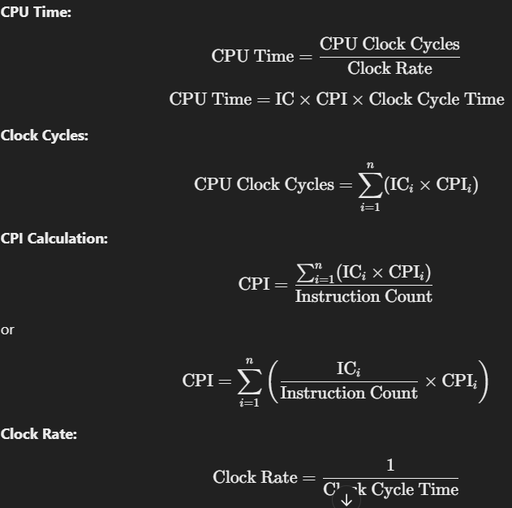
Fallacies and Pitfalls NOT INCLUDED
Misbeliefs (Fallacies)
- Microprocessors as a Silver Bullet: The move to multiprocessors wasn't due to some breakthrough in parallel programming, but rather the limits of previous designs. Multiple processors per chip don’t guarantee lower power or automatic performance improvements.
- Performance and Energy Efficiency: Hardware performance enhancements do not always correlate with better energy efficiency. Higher clock speeds, for example, can result in more energy consumption despite improved performance.
- Benchmark Validity: Benchmarks can lose their relevance over time, as optimizations target specific benchmarks and ignore real-world performance. Moreover, benchmarks are vulnerable to manipulation or "benchmarketing."
Pitfalls
- Amdahl’s Law: Optimizing features without measuring their impact can lead to disappointing results. Amdahl's Law teaches that improvements to non-critical parts of a system won't yield significant performance gains.
- Single Point of Failure: In complex systems, improving one part without considering the overall system can lead to weak points that undermine the reliability. Fault-tolerant systems need to ensure redundancy to avoid single points of failure.
- Exponential Laws Ending: The idea that exponential progress in areas like transistor scaling (Moore’s Law) and power efficiency (Dennard scaling) would continue indefinitely was flawed. As technology matured, these trends slowed down due to physical limitations.
Reliability and Failure Rates
- Disk MTTF (Mean Time to Failure): The MTTF of disks is misleading. A typical MTTF may suggest disks last for a long time (e.g., 140 years), but this is based on unrealistic assumptions. In practice, disks fail much sooner, with annual failure rates of around 0.9%.

NOT INCLUDED
Aspect | Smartphone CPUs | PC CPUs
Architecture | Uses ARM architecture, optimized for power efficiency and lower heat generation, making them ideal for battery-powered devices. | Uses x86 architecture (Intel/AMD), designed for higher performance with more cores and threads for complex computing tasks.
Performance | Designed for lower performance, focusing on efficient multitasking, handling everyday tasks, and running mobile applications. | Offers higher clock speeds, more cores, and greater processing power, making them suitable for demanding tasks like gaming, video editing, and software development.
Power Consumption | Prioritizes energy efficiency to extend battery life. Performance is often throttled to conserve power during less demanding tasks. | Consumes more power, especially during intensive workloads. Typically paired with larger cooling systems to manage heat.
Use Cases | Optimized for mobile applications, multitasking, and connectivity features like cellular and Wi-Fi. | Designed for a broader range of applications, including high-performance computing, gaming, and professional software.

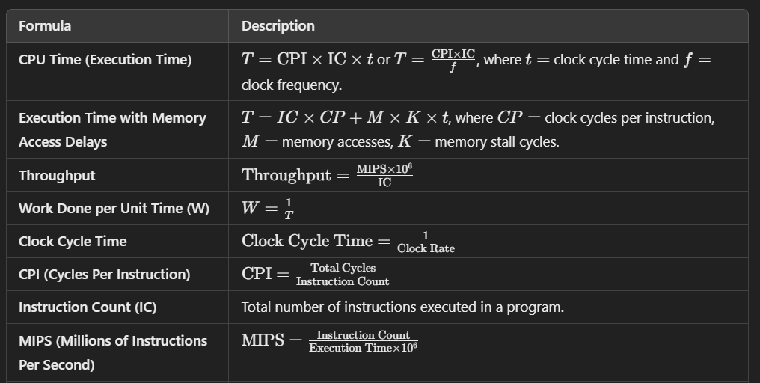
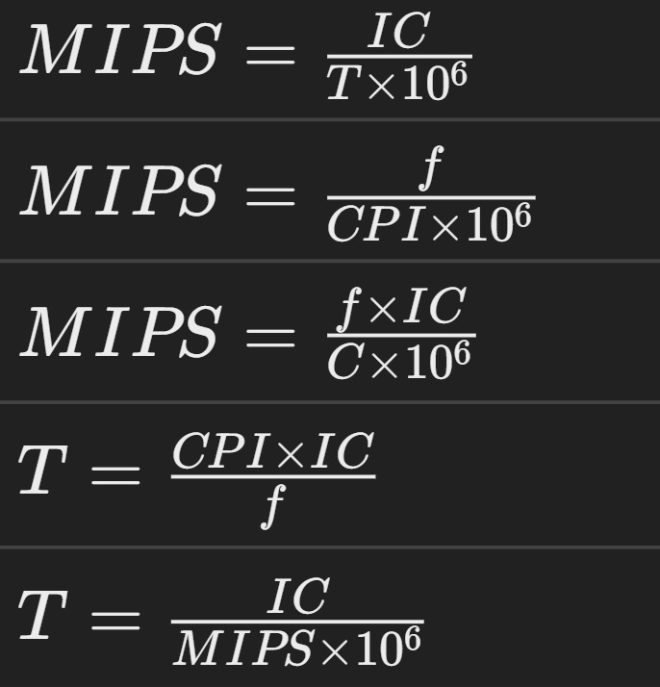
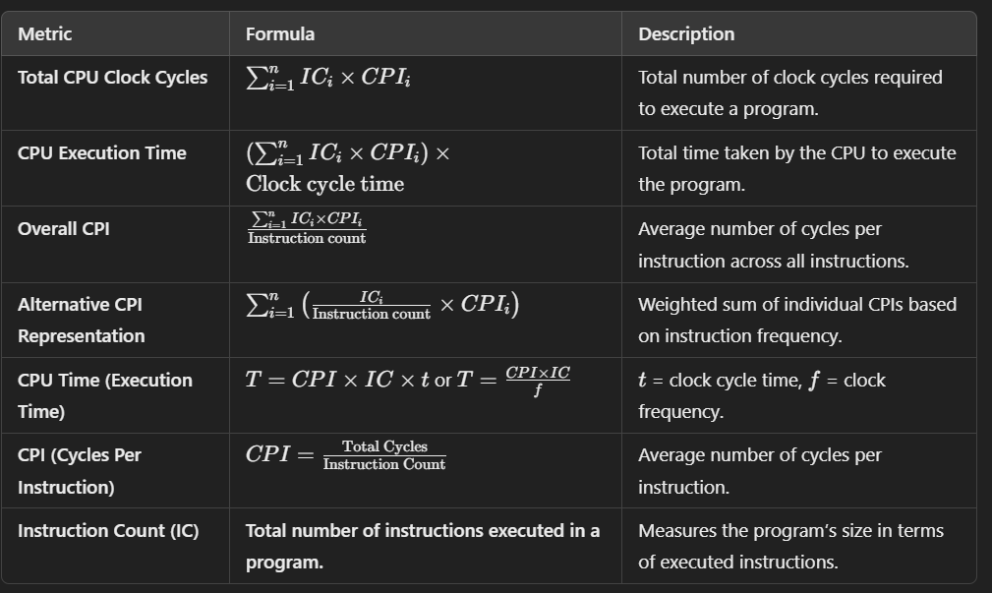

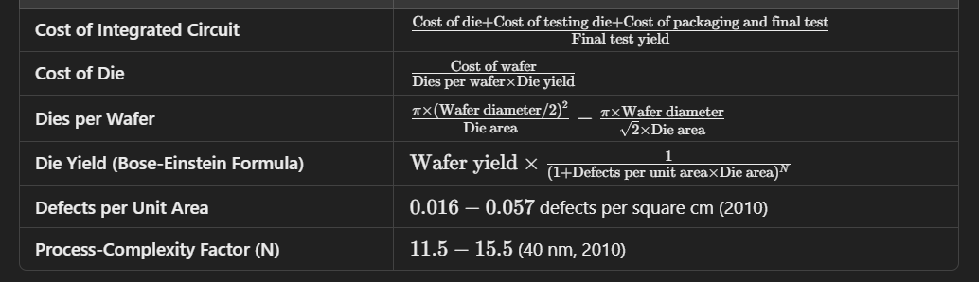
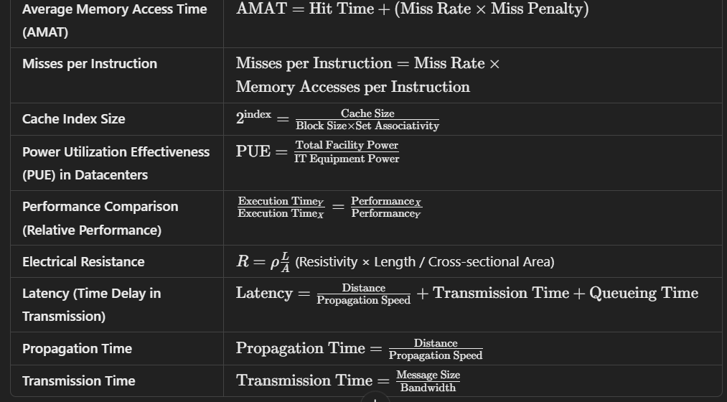
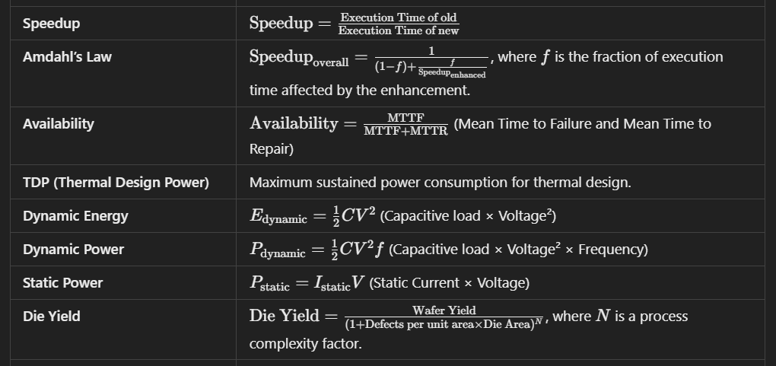
BOOK EXAMPLE NUMERICALS

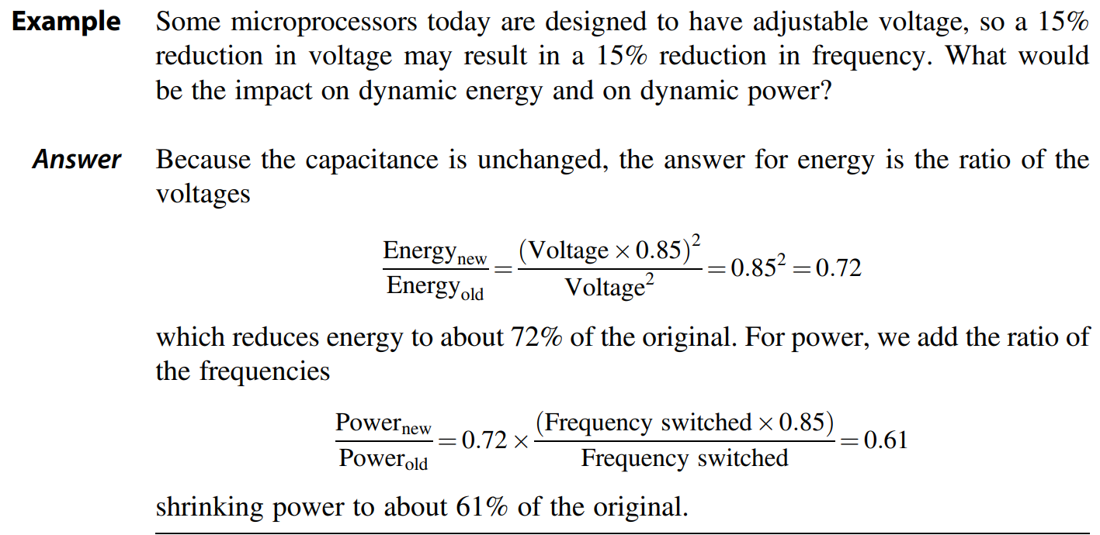
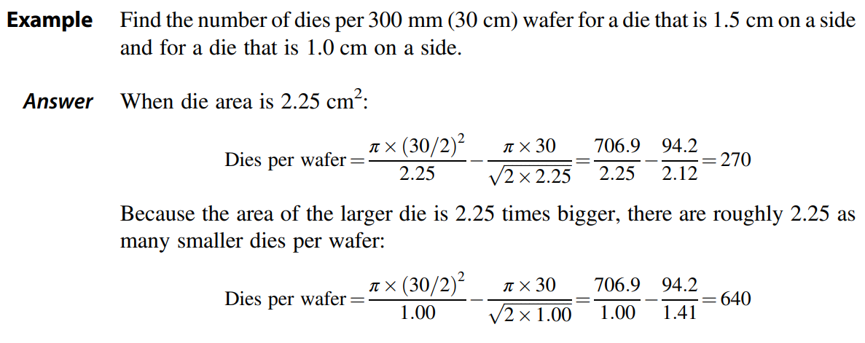
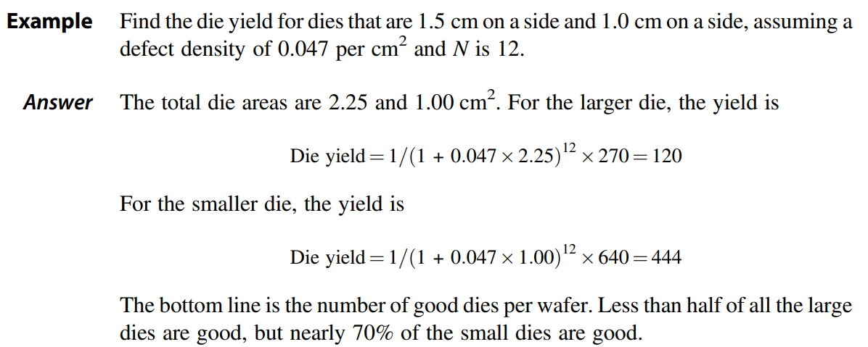
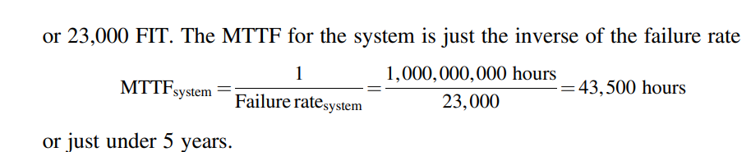
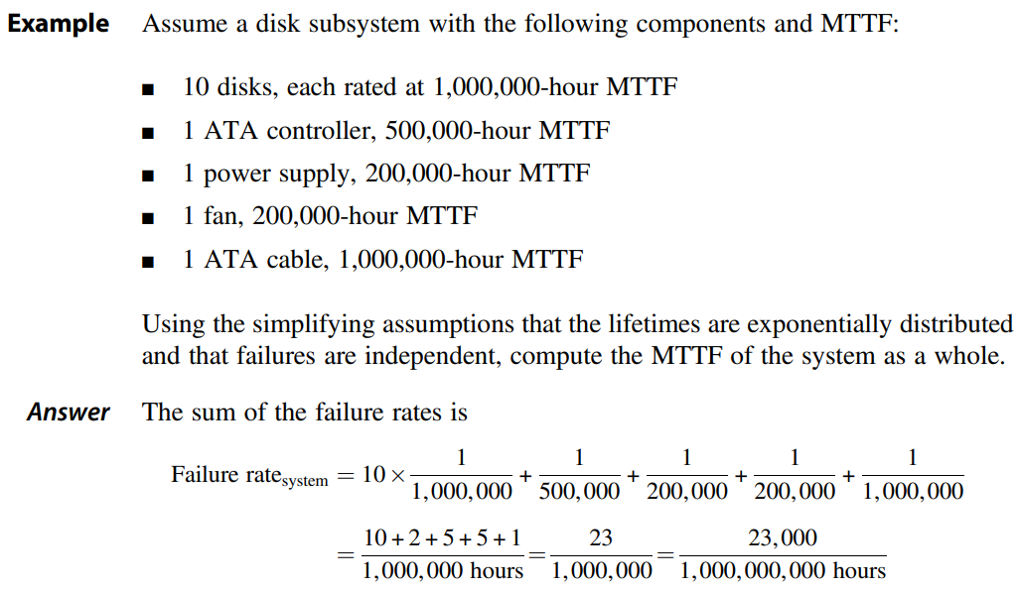

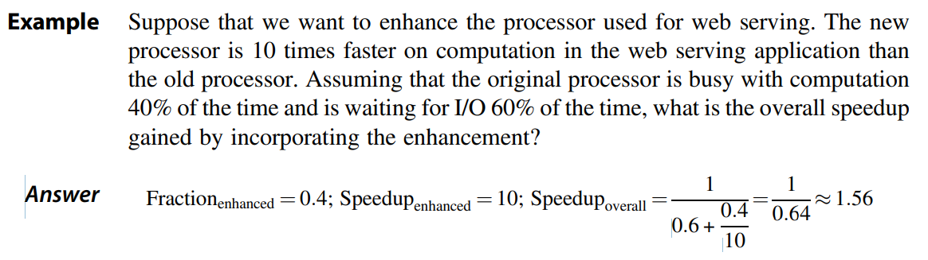
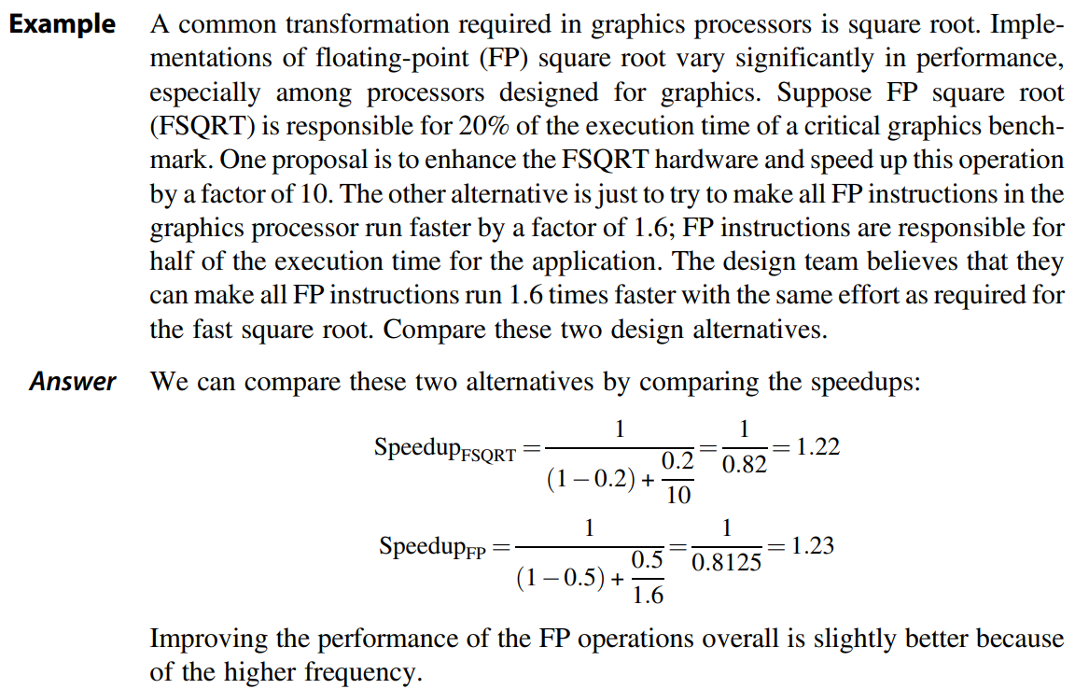
I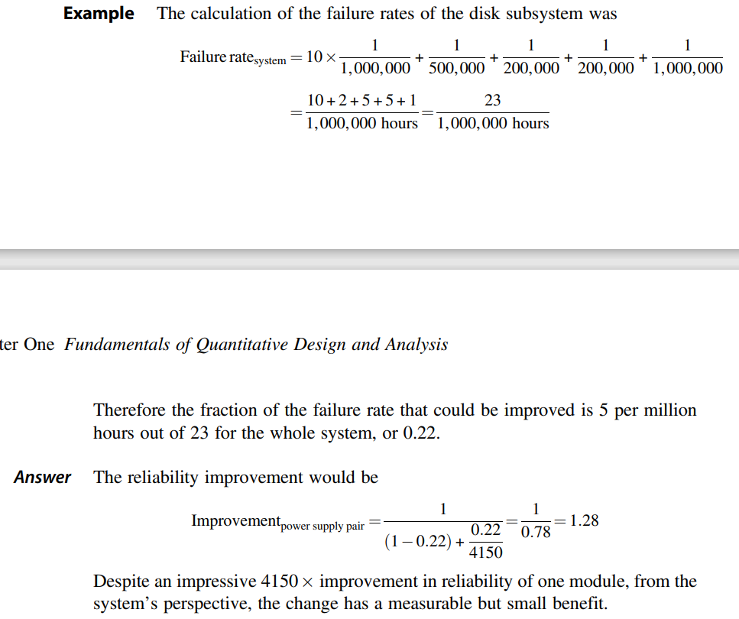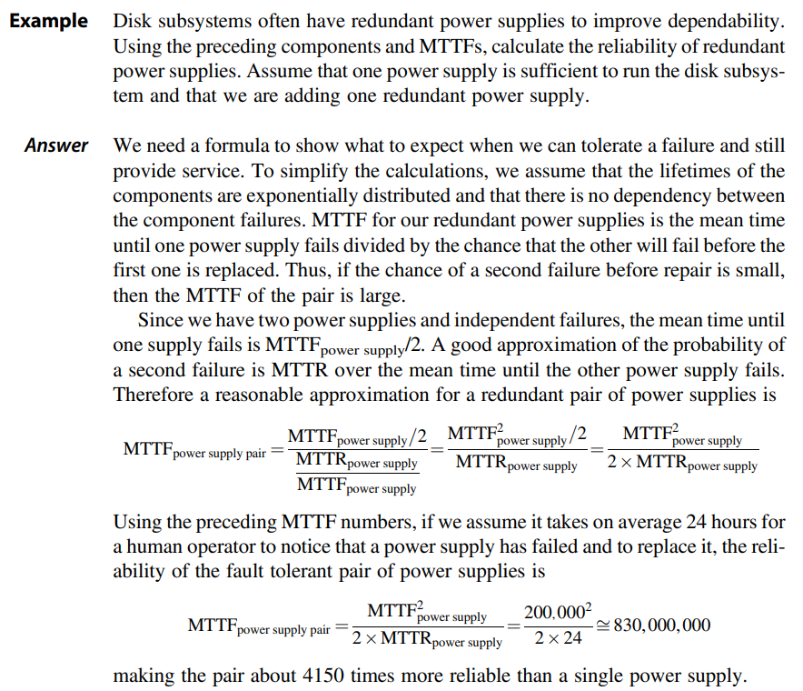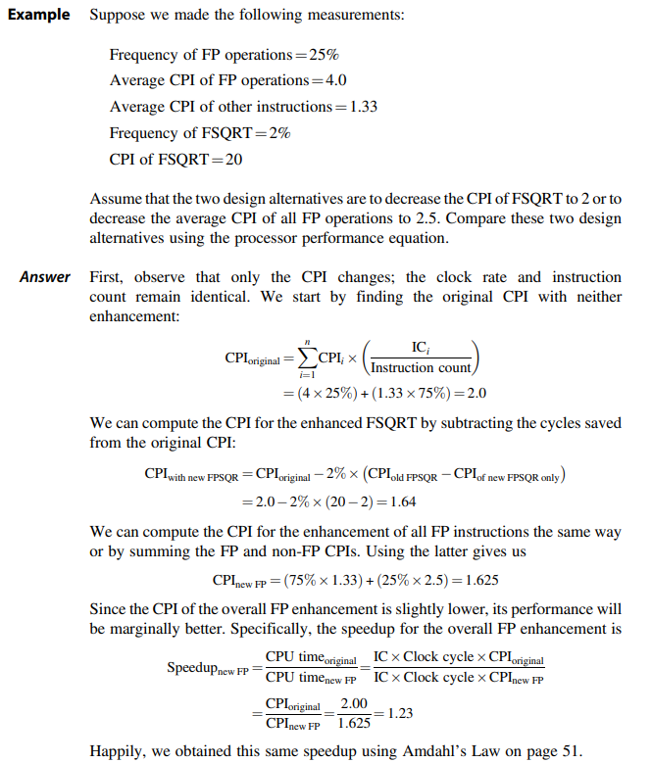

MORE CLASS EXAMPLE QS IN NOTES

